MSPADC--Operation
- Ensure that Python and its Pyserial module are installed on your computer. Ensure that your computer has a serial port or another way of connecting to the board’s serial port.
- Connnect power and serial cable to computer. On powering up, the LED should blink once, then twice shortly thereafter. It will then stay on, signaling that it is awaiting commands.
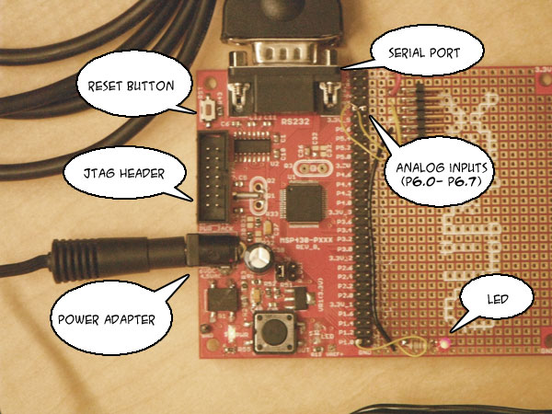
Figure 1: Important MSPADC features
- Locate folder of important GSS files on your desktop.
- Run GUI.pyw. You should see something like the picture below. Select the COM port of the serial cable attached to your computer, then press “Open.” It is recommended that you then press “Test” to verify that the connection is working. After you are finished, press the “forward” button.
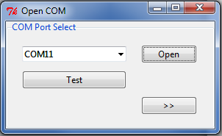
- You should see something like the picture below. Select the following criteria for your sampling session:
  - Start Collection on Send will cause the GSS to begin sampling immediately following receiving commands instead of starting from a paused state.
  - Bits of Representation represents how many bits large all samples will be. The max is the largest possible value from the ADC, 12 bits. Changing this number to a value 8 or below will not cause samples to take up 1 byte instead of 2.
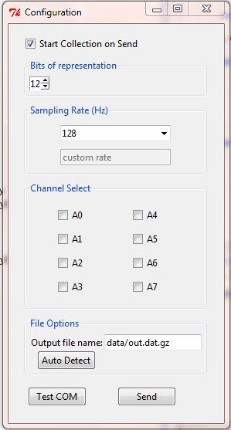
  - Sampling Rate represents how often the samples will be taken per second. Several presets can be selected from the dropdown or a custom value between 0 and 255 may be chosen
  - Channel Select selects which channels will report meaningful data back. Deselected channels will always report a 0xFFFF back as their value
  - File name: it is recommended that you keep the .dat.gz suffix to your chosen file name. Auto detect suggests a name for you.
Once you are done, click “send.”
- You should see a window like the one below. The LED should be blinking at a constant rate, indicating it is sampling. At any time you may press “Pause” to pause sampling, and then press “play” to resume..
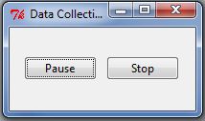
- Press stop to end sampling. A file will be created in a folder named “data.” Said folder will be a subdirectory to the location of GUI.pyw file.
- The output file is in a GZipped format. The user may use 7zip or another file compression software to unzip it. A more direct method is included with the package and is detailed below:
  - Start a command prompt in the folder. Windows users can do this quickly by shift+right clicking the GSS folder and selecting “Open command Window here.”
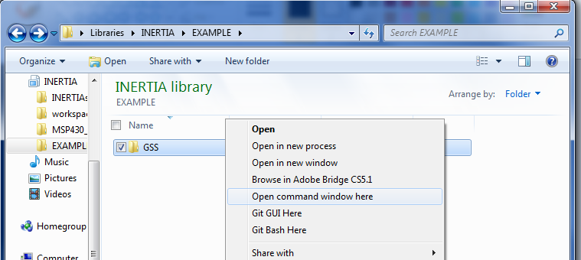
  - Enter the command gzip –d [filename]. Upon returning to the folder, the .gz suffix should be removed from the filename and it should be decompressed.
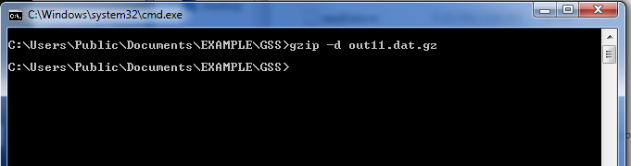
- In MATLAB, use the readData(filename) function on your file to read it into the workspace. The data takes the form of an 8 x N array of doubles, where N is the number of samples. As mentioned above, channels not used will have a constant value of 0xFFFF (65535).
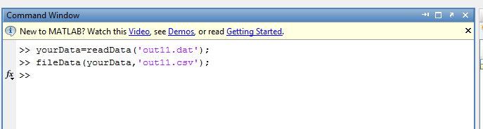
- If desired, the data can be converted into a CSV by using the fileData(data, filename) command.

